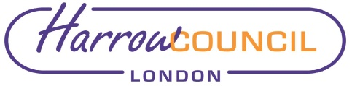
Report for: | Health and Wellbeing Board
Date of Meeting: | Tuesday 24th November
Subject: | Focus for Healthwatch Harrow October 2020 - March 2021
Responsible Officer: | Paul Hewitt
Public: | Yes
Wards affected: | All
Enclosures: | Information Report only

Section 1 – Summary and Recommendations
Report for Information

This report is being shared to raise awareness of the revised focus of Healthwatch Harrow. This was discussed and supported at the Health and Care Executive Meeting, which drives the Integrated care partnership in Harrow . Members and Partners are already aware and supportive, but this also needs to be in the public domain and via the Health and Well-Being Board which is a statutory board. .

Recommendations:
The Board is requested to note the report. No decision is required as the report is for information only.

Section 2 – Report

Financial Implications/Comments
None

Legal Implications/Comments
None

Risk Management Implications
None

Equalities implications / Public Sector Equality Duty

As this is an information report ,no Equality impact assessment is required
Please see: https://harrowhub.harrow.gov.uk/downloads/file/9714/committee_report_templates_-_implications_guidance

Council Priorities
Not relevant in this case

Section 3 - Statutory Officer Clearance (Council and Joint Reports)

Not Applicable

Section 4 - Contact Details and Background Papers
Contact: Paul Hewitt Corporate Director for People Services

paul.hewitt@harrow.gov.uk

